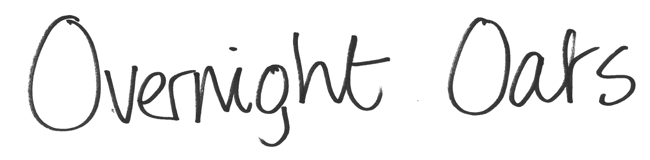

Ingredients
Overnight oats (makes 2 portions) CHO Protein
1 grated eating apple 15g
50g jumbo porridge oats 35g 5g
25g mixed nuts 6g
25g mixed seeds 4g
¼ teaspoon ground cinnamon
100g Greek/Greek Style/Icelandic yogurt 5g 6-10g
100ml cold water
1 banana 20g
Method
Mix all ingredients together except banana and half the nuts. Divide into 2 and leave overnight. In the morning add the nuts and half a banana per portion
Each portion: 35g carbs + 10g protein
www.digibete.org/strike-the-breakfast-spike

