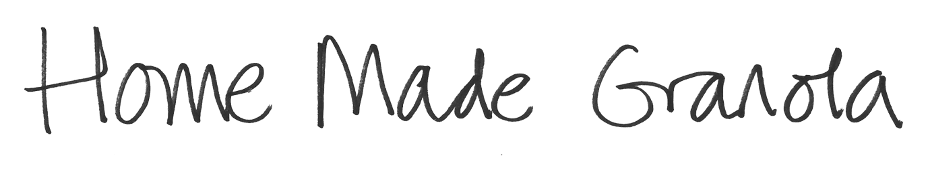

Here’s a great recipe to try. It accompanies the Homemade Granola film with Frances and Francesca. This recipe makes 15 x 55g portions and if you store it in a jar it will last for up to a month.
Ingredients
Makes 15 x 55g portions CHO Protein
2 tablespoons vegetable oil
125ml maple syrup 80g
2 tablespoons honey 28g
1 teaspoon vanilla extract
300g jumbo/rolled oats 213g 33g
50g sunflower seeds 10g 10g
4 tablespoons sesame seeds 7g
50g pumpkin seeds 6g 9g
150g flaked almonds 15g 30g
50g sultanas 35g
50g dried cranberries 40g
Each portion: 28g carbs + 6g protein
Method

Heat oven to 150C/fan 130C/gas mark 2
Mix oil, syrup, honey and vanilla in a bowl
Add oats, seeds and nuts and mix well
Spread ingredients evenly on 2 lined baking trays and bake for 15 minutes
Add dried fruit evenly and cook for another 10-15 minutes
(If you forget and add it all together, bake everything for 25 minutes but stir halfway so fruit doesn’t burn)
Leave to cool on a rack and then mix up together and store in a jar for up to a month
Serve with 125g Greek yogurt (8g protein, 6g carbs)

Bon Appétit

www.digibete.org/strike-the-breakfast-spike

