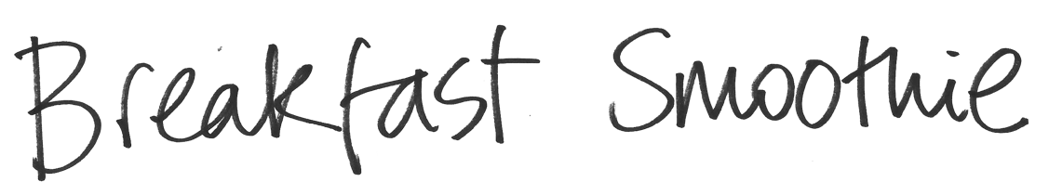
A breakfast smoothie is a great/refreshing way to start the day. Here’s a quick and easy recipe from Frances and Francesca for you to try. If you make it the night before, it’ll be ready and waiting for you to enjoy the following morning.
Ingredients
Fruit and Yogurt Smoothie (makes 2 portions) | CHO | Protein
100g frozen berries (still frozen) | 8g
½ banana | 10g | 10g
100g Greek/Greek style/Icelandic yogurt | 5g | 8-10g
125ml semi skimmed milk | 7g | 3g
20g jumbo/large oats | 15g | 2g

Method
Mix all ingredients in liquidiser/ blender and divide by 2. This can be made the night before. Shake or stir before serving.
Each portion: 23g carbs, 7-8g protein
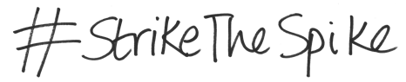
www.digibete.org/strike-the-breakfast-spike

