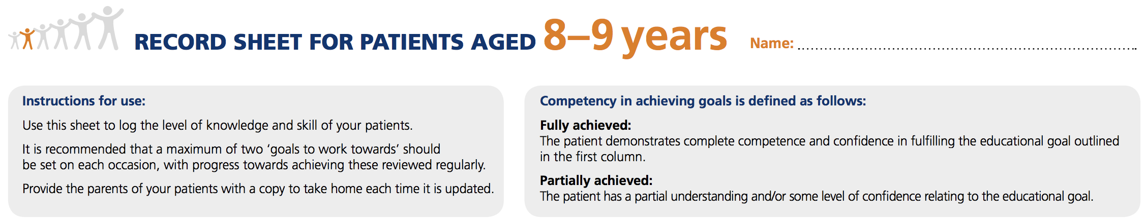
Name:
Educational Goal | FULLY ACHIEVED  (√ / NA) | PARTIALLY ACHIEVED  (√ / NA) | GOALS TO WORK TOWARDS |  |  | DATE & SIGNATURE
 |  |  | GOAL |  | REVIEW DATE
Diabetes Knowledge
The child should be able to say in their own words:
- That they have diabetes
- That their body needs insulin
- Where on their body they can administer insulin
- That they can live like other children and feel well when they eat regularly, take insulin and keep their blood glucose level steady
The child should know that:
- They will always have diabetes.
- Diabetes cannot be caught from other people (not contagious)
- No-one knows for sure why some people get diabetes
- It is not their fault, nor anybody else’s fault, that they have diabetes
Food: The child should:
- Know the number of meals they need at school, and when food should be eaten
- Start to recognise carbohydrate-containing foods and drinks and the carbohydrates must be counted
Educational Goal | FULLY ACHIEVED  (√ / NA) | PARTIALLY ACHIEVED  (√ / NA) | GOALS TO WORK TOWARDS |  |  | DATE & SIGNATURE
 |  |  | GOAL |  | REVIEW DATE
Food continued…

- Recognise which foods should be limited in quantity and the best time to eat them
- Know how many portions of fruit and vegetables they should eat per day
- Recognise types of drinks they can drink freely without affecting their blood glucose
Exercise
It is understood that it is the parent’s responsibility to encourage active play and exercise, and that if the child participates in sports, it is the parent’s responsibility to supply extra food or adjust the insulin dose accordingly. Your child’s target blood glucose pre-exercise is mmol/l. Do not exercise if ketones are above mmol/l.
The child should know that:
- Blood glucose levels should be checked before exercise and active play
- Exercise and sports require more food and possibly less insulin
Insulin
Insulin administration is the parent’s responsibility.
- Parents/carers may encourage the child to assist by allowing them to prepare the pen device and point out the injection site to be used
- At this age, the child can be encouraged to inject themselves, but always under supervision
- If using an insulin pump, the child can start to button-push under supervision
- The parent/carer should supervise good injection/infusion site care including the rotation of injection/infusion sites
- The child should understand that the amount of insulin they have during the day will vary depending on how much carbohydrate they eat

Educational Goal | FULLY ACHIEVED  (√ / NA) | PARTIALLY ACHIEVED  (√ / NA) | GOALS TO WORK TOWARDS |  | DATE & SIGNATURE
 |  |  | GOAL | REVIEW DATE
Blood Glucose Testing

- The child should know that the blood glucose test measures the level of glucose in the blood. They should know why the test is needed
- The child should be able to test their own blood glucose
- The parent/carer must evaluate the result
- The parent/carer must keep records of the child’s blood glucose readings and current insulin doses
Hypoglycaemia or Hypo (blood glucose level less than mmol/l)
The child should know:
- Their own symptoms of low blood glucose level an d know how much glucose (or a similar source of sugar) they need to correct the situation
- They have to tell an adult how they feel straight away
- Their blood glucose must be tested to confirm that they are hypoglycaemic
- They have to take glucose tablets or a sugary drink
- Their blood glucose should be retested 15 minutes later to confirm recovery
- They should have a snack if they are not due to eat a meal or snack or if they are about to exercise
- It is understood by parents/carers that they will have the opportunity to revise how to use glucagon annually, and must check the expiration date of stored glucagon regularly

Educational Goal | FULLY ACHIEVED  (√ / NA) |  | PARTIALLY ACHIEVED  (√ / NA) | GOALS TO WORK TOWARDS |  | DATE & SIGNATURE
 |  |  |  | GOAL | REVIEW DATE
Hyperglycaemia or HYPER (blood glucose level more than mmol/l)

- The child should know when the blood glucose level is reading too high and inform an adult
- They should realise the importance of testing for ketones at this time
Illness
- The child should know that they must always turn to an adult for help if they feel ill
Eating or Sleeping Away from Home
It is understood by all that the insulin doses and when to inject are still the parent’s responsibility
- The child can now inject insulin by themselves
- When the child is away from home, correctly instructed adults must be there to supervise at all times
- Parents/carers must give guidance to these adults regarding suitable foods and drinks
- As the child becomes more socially independent (and may be moving out into different social situations), it is advisable for them to carry some form of identification stating that they have been diagnosed with diabetes and require insulin
Emotional Wellbeing
- Children should understand that they (and their parents/carers) can get ‘fed up’ with diabetes at times, or have worries about diabetes
- They should understand that they may experience unwanted comments or bullying in school
- They should feel supported by a clinical psychologist attached to them (if available)
- The child should receive a psychological assessment each year

Record any other education provided or notes here:

Authorisation date: Date of next revision:

