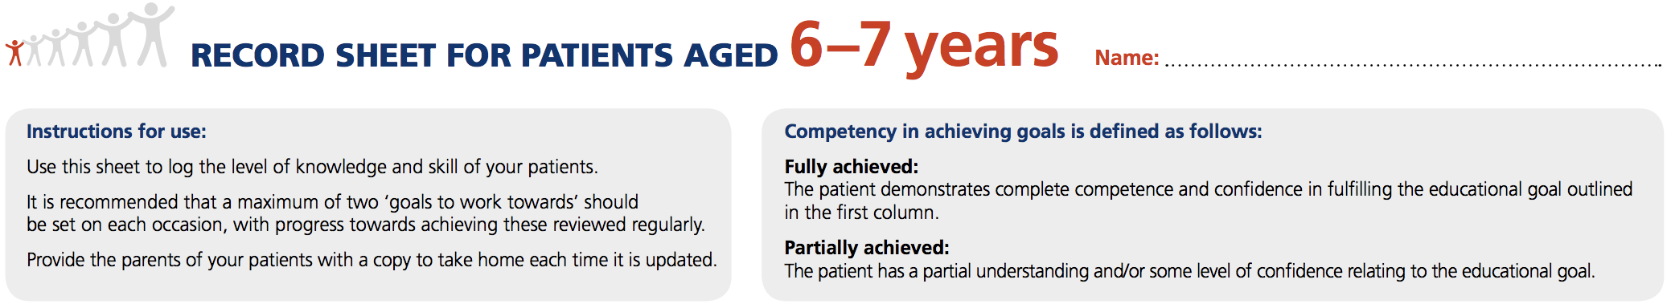
Name:
Educational Goal | FULLY ACHIEVED  (√ / NA) | PARTIALLY ACHIEVED  (√ / NA) | GOALS TO WORK TOWARDS |  |  | DATE & SIGNATURE
 |  |  | GOAL |  | REVIEW DATE
Diabetes Knowledge
It is understood that parents/carers are responsible for taking care of their child’s diabetes, but that their child may be allowed to assist under their supervision.

The child should be able to say in their own words:

- That he or she has diabetes
- That their body needs insulin
- Where on their body they can inject their insulin
- When they receive insulin and eat regularly, they feel well and can live like other children
The child should know that:
- They will always have diabetes.
- Diabetes cannot be caught from other people (not contagious)
- No-one knows for sure why some people get diabetes
- It is not their fault, nor anybody else’s fault, that they have diabetes
Educational Goal | FULLY ACHIEVED  (√ / NA) | PARTIALLY ACHIEVED  (√ / NA) | GOALS TO WORK TOWARDS |  |  | DATE & SIGNATURE
 |  |  | GOAL |  | REVIEW DATE
Food
- The child should know the number of meals they need, and when to eat at school or at nursery
- They may snack during school breaks or when an adult reminds them
- The child should start to recognise carbohydrate-containing foods and drinks at mealtimes, and start to understand that the carbohydrates in this food are counted
- When sweets are offered, the child should explain they have diabetes
- If sweets are offered, the child can either eat a small amount and take the rest home or take them all home
- The child should know what types of drinks they can have freely without affecting their blood glucose levels
Exercise
It is understood that it is the parent’s responsibility to encourage active play and exercise, and that if the child participates in sports, it is the parent’s responsibility to supply extra food or adjust the insulin dose accordingly. Your child’s target blood glucose pre-exercise is mmol/l. Do not exercise if ketones are above mmol/l.
The child should know that:
- Blood glucose levels should be checked before exercise and active play
- If they participate in sports, they understand that it is the responsibility of their parent/carer to supply extra food and adjust the insulin dose if needed
- No-one knows for sure why some people get diabetes
- It is good if they can explain, in simple words, the relationship between food, exercise and insulin

Educational Goal | FULLY ACHIEVED  (√ / NA) | PARTIALLY ACHIEVED  (√ / NA) | GOALS TO WORK TOWARDS |  | DATE & SIGNATURE
 |  |  | GOAL | REVIEW DATE
Insulin
It is understood by all that insulin administration is the parent’s responsibility.
- The parent/carer may allow the child to assist in preparing the pen device, pointing out the injection site to be used, then counting to 10 once the insulin is delivered
- At this age, the child can be encouraged to inject themselves, but always under supervision
- The parent/carer should encourage their child to use all available injection/infusion sites and not develop any favourites
- If the child uses an insulin pump, they may be able to button-push under supervision
Blood Glucose Testing
- The child may assist with blood glucose testing, but only under the supervision of an adult
- The child should know that the blood glucose test shows how much glucose is in their blood
Hypoglycaemia or Hypo (blood glucose level less than mmol/l)
Children who have experienced a low blood glucose level should be able to describe their symptoms.
They should know that:
- They have to tell an adult how they feel straight away
- Their blood glucose must be tested to confirm that they are hypoglycaemic
- They have to take glucose tablets or a sugary drink
- Their blood glucose should be retested 15 minutes later to confirm recovery
- They should also take a snack if they are not due to eat a meal or snack, or about to exercise
- It is understood by parents/carers that they will have the opportunity to revise how to use glucagon annually, and must check the expiration date of stored glucagon regularly

Educational Goal | FULLY ACHIEVED  (√ / NA) | PARTIALLY ACHIEVED  (√ / NA) | GOALS TO WORK TOWARDS |  | DATE & SIGNATURE
 |  |  | GOAL | REVIEW DATE
Hyperglycaemia or HYPER (blood glucose level more than mmol/l)
The child should start to recognise when their blood glucose numbers are too high. It is understood by parents/carers that they must keep records of the child’s blood glucose levels and insulin doses in order to monitor blood glucose control and to help them adjust the insulin dose as required. It is understood that this is a very important task.
Illness
- The child should know that they must always turn to an adult for help if they feel ill
Emotional Wellbeing
- The child should understand that they, and their parents/carers, can get ‘fed up’ with diabetes at times, or have worries about diabetes
- The child should understand that they may experience unwanted comments or bullying in school
- The child should feel supported by a clinical psychologist attached to their team (if available)

Record any other education provided or notes here:

Authorisation date: Date of next revision:

