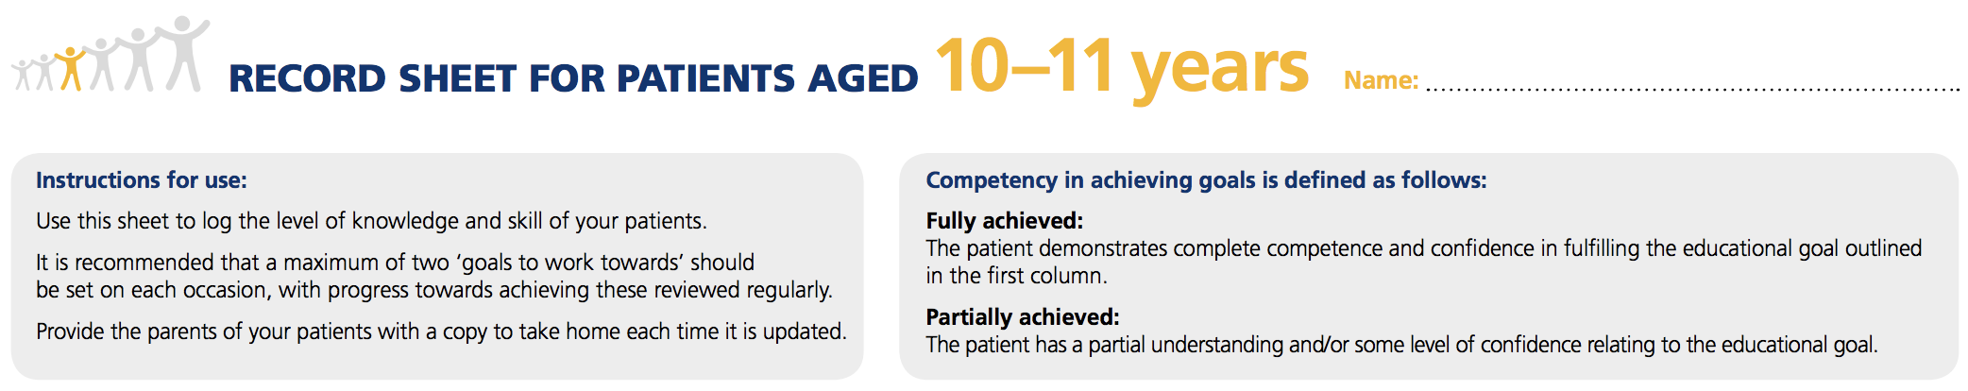
Name:
Educational Goal | FULLY ACHIEVED  (√ / NA) | PARTIALLY ACHIEVED  (√ / NA) | GOALS TO WORK TOWARDS |  | DATE & SIGNATURE
 |  |  | GOAL | REVIEW DATE
Diabetes Knowledge
The child should know how insulin works. For example, they should understand that insulin lowers their blood glucose level after a meal.
It is understood by all that the child will still need some background information about diabetes from their parents/carers, and that they will continue to oversee their diabetes care.
Food
Children should:
- Know the number of meals they need at school and after school, and when food should be eaten
- Know how many sweets they are allowed to eat as part of a healthy, balanced diet.
- Be able to describe a healthy, balanced meal.
- Know how many portions of fruit and vegetables they should eat a day
- Be able to identify different sources of carbohydrate, such as, fructose, sucrose, lactose and starch
- Start to learn how to count carbohydrates with the help of their parents/carers.

Educational Goal | FULLY ACHIEVED  (√ / NA) | PARTIALLY ACHIEVED  (√ / NA) | GOALS TO WORK TOWARDS |  | DATE & SIGNATURE
 |  |  | GOAL | REVIEW DATE
Exercise
Children should:
- Know that their target blood glucose pre-exercise is mmol/l. Do not exercise if ketones are above mmol/l.
- Understand how insulin, food and exercise are related.
- Know that blood glucose levels should be checked before exercise.
- Know which readings mean that they must take a ketone test, and which readings mean they must eat more carbohydrate before exercising.
- Know what precautions to take when exercising or playing sports.
- Engage in some sort of physical activity for at least 60 minutes a day.
Insulin
Children should know:
- When to administer insulin and be able to do it independently with their pen or pump.
- Their insulin dosages – but they should also know not to change them without speaking to their parents/carers or diabetes team.
- How to care for their injection/infusion sites, including rotating their injection/infusion sites and not developing any favourites.
- Which insulin is rapid (quick) acting, and which is long (slow) acting.
- How to store their insulin.
If on an insulin pump they should know:
- How to administer an insulin injection by pen in case of pump failure, and help perform an injection/infusion set change.

Educational Goal | FULLY ACHIEVED  (√ / NA) | PARTIALLY ACHIEVED  (√ / NA) | GOALS TO WORK TOWARDS |  | DATE & SIGNATURE
 |  |  | GOAL | REVIEW DATE
Blood Glucose Testing
Children should:
- Know why their blood glucose level is tested frequently, when to test it and the most important blood testing times.
- Be able to test their own blood glucose level and use a bolus advisor if required.
- Know what blood glucose level they are aiming to achieve.
- Be able to explain how their blood glucose level relates to insulin, food and exercise.
- Take part in conversations about their own HbA1c target.
It is important for the parent/carer to keep records of their child’s blood glucose levels and insulin doses. This is to monitor blood glucose control and to adjust the insulin dose, if needed.
Hypoglycaemia or HYPO (blood glucose level less than mmol/l)
Children should:
- Know at what number their blood glucose level is low.
- Be able to explain the reasons for low blood glucose levels.
- Know their own symptoms of low blood glucose.
- Know how to correct their own blood glucose level with the right number of glucose tablets or a sugary drink.
- Know that their blood glucose should be retested 15 minutes later to confirm recovery.
- Know that they may require a snack if their next meal is more than 1-2 hours away, or if they are exercising
- Understand that they cannot always rely on warning signs and symptoms and must test their blood glucose levels regularly
It is understood by parents/carers that they will have the opportunity to revise how to use glucagon annually, and must check the expiration date of stored glucagon regularly.

Educational Goal | FULLY ACHIEVED  (√ / NA) |  | PARTIALLY ACHIEVED  (√ / NA) | GOALS TO WORK TOWARDS |  | DATE & SIGNATURE
 |  |  |  | GOAL | REVIEW DATE
Hyperglycaemia or HYPER (blood glucose level more than mmol/l)
Children should:
- Be able to explain the possible reasons for high blood glucose levels.
- Recognise the signs of high blood glucose.
- Know that they must test their blood glucose and test their blood for ketones.
- Know when their blood glucose level is reading too high.
- Know that they must inform an adult immediately if their blood glucose level is too high of if ketones are present in their blood.
Illness
Children should know:
- That they must inform an adult when they are feeling ill.
- That special sick day rules apply during illness.
- That testing for ketones in their blood at this time is important even if their blood glucose is not out of range.
- That they need to eat and drink even if they don’t feel like it.
- What the results of the tests mean (or begin to understand).
Long-term Complications
- The child should start to understand why good glucose control is very important.
- They should understand the need for good glucose control and that taking care of themselves – for example taking care of their feet – protects them from getting complications in the future.
- They should start to understand the relationship between HbA1c levels and long-term complications, and agree individual targets with their diabetes team and parents/carers

Educational Goal | FULLY ACHIEVED  (√ / NA) | PARTIALLY ACHIEVED  (√ / NA) | GOALS TO WORK TOWARDS |  | DATE & SIGNATURE
 |  |  | GOAL | REVIEW DATE
Eating or Sleeping Away from Home
- The child should be able to handle a few days away from home as long as an adult is present to supervise their diabetes care at all times.
- As the child is becoming more socially independent (and may be moving out into different situations), it is advisable for them to carry some form of identification stating that they have been diagnosed with diabetes and require insulin.
Moving to Secondary School
- The child will be living through a time of change as he or she moves from primary to secondary school.
- The child should discuss how to manage changes in the timetable of their school day with their diabetes team.
- The child should be provided with help to develop independence skills such as using public transport and coping with going to the school cafeteria.
Emotional Wellbeing
Children should understand that:
- They can get ‘fed up’ with diabetes at times, or have worries about their diabetes, and that this is quite normal.
- If they need emotional support or help with managing the impact of their diabetes on their life they will be offered the chance to talk to the clinical psychologist attached to their diabetes team (if available).
- At least once a year, they will be asked questions about their emotional wellbeing to check whether they need extra support.
- They will have regular opportunities to discuss their thoughts and feelings, including any worries about their diabetes, experiences of bullying or concerns about matters such as body image.
- They can ask for support from their diabetes team if any aspects of their diabetes care are causing major conflict at home or with friends.

Record any other education provided or notes here:

Authorisation date: Date of next revision:

